Page 1 - Home Page

<Opening section – 4 images and text will animate one after another in the same area>

- We help ALIGN your workforce with your organizational goals.

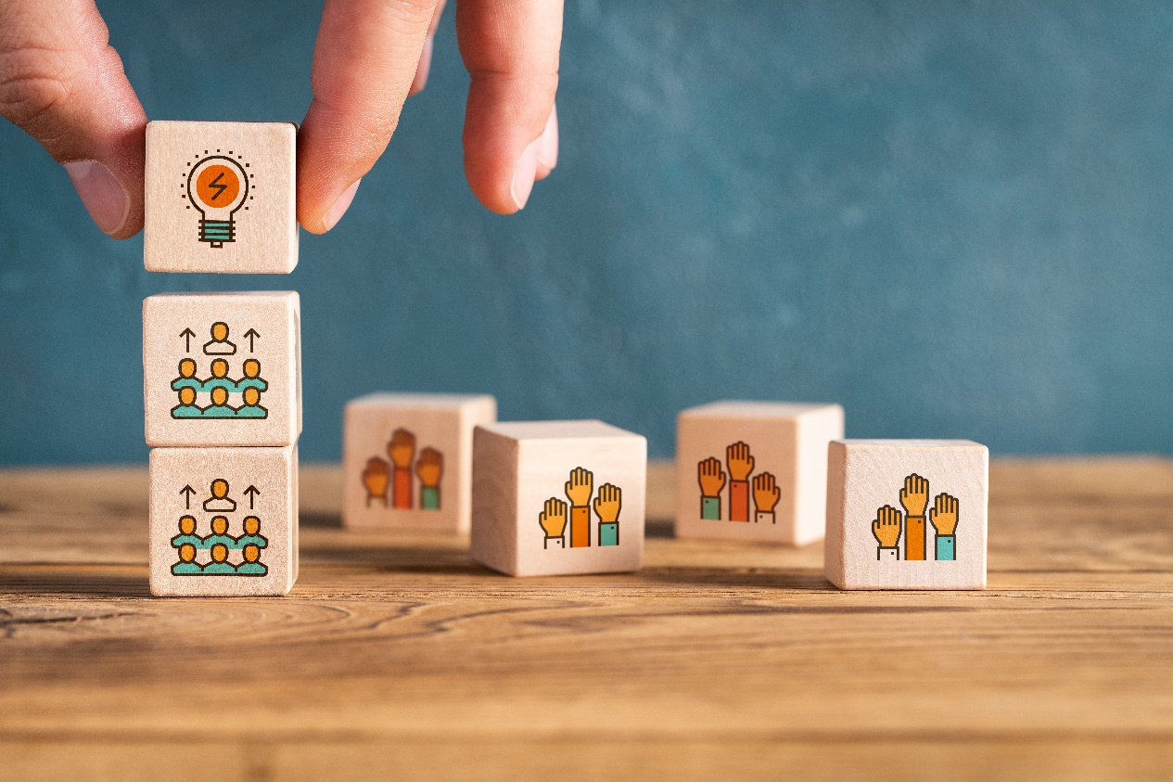

- We help EMPOWER your human capital to reach their peak performance.



We IMPROVE training performance, engagement and outcomes.



We craft IMPACTFUL, SUSTAINABLE and MEASURABLE learning experiences.



<Button 1: Schedule a Consultation>

Who Can We Help?

Organizations that believe in lifelong learning and empowering their human capital. TLP helps organizations create an organic, sustainable and performance-oriented learning ecosystem with learners at its heart.

<Our Services>

<Images with captions>

 Needs Analysis

 Strategic Planning

Learning Ecosystem Building

Instructional Writing

Graphic and Media Design

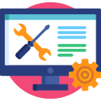eLearning Development

Learning Evaluation

<blog for each of these above will be linked later>

Delivery Formats

Self-paced Training/E-learning

Instructor/Virtual-led Training

Video-based Training

Game-based Training

Simulation-based Training

Onbaording & Everboarding

Compliance Training

Leadership Training

<1 Portfolio video for each of these above will be linked>

<Blogs>



How your employees perceive your L&D efforts?



2. Needs Analysis - Invest Now to Save Future

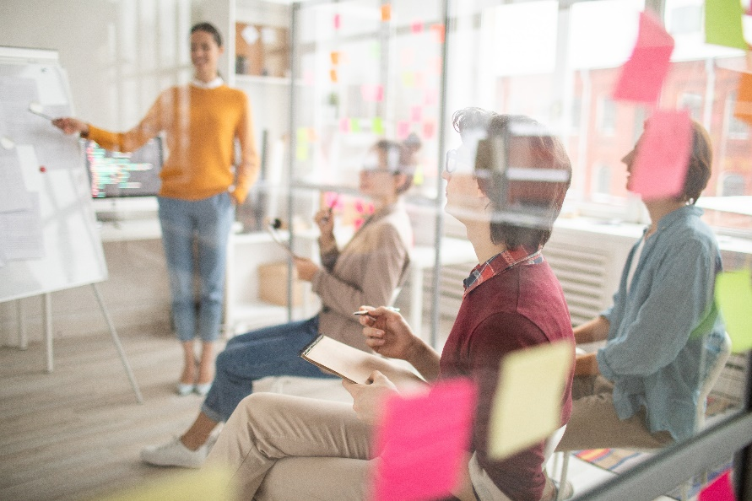
3. How to choose the correct delivery format for your training?

Page 2 – About Us

Is your workforce aligned with the goal that your organization is currently chasing? Do you feel that you need to EMPOWER your people in order to accomplish that goal. One key aspect of employee empowerment is to provide them with relevant, personalized learning and development opportunities. That’s exactly our craft - enabling people to perform - and we know it well.

At TLP, we follow evidence-based approaches and proven learning principles and partner with you and your workforce to deeply understand and uncover the probable knowledge, skills or habits gaps and strategize effective interventions to bridge them. Thus, enabling you all to take that leap towards your organizational goal. These interventions will help your organization align goals, boost performance, retain talent, and grow your business.

To accomplish this, we have a thorough Agile Design and Delivery framework in place so that we continue to evolve the learning experiment until your needs are fully met. We take pride in our approach to facilitating Deep Needs Analysis and designing bespoke learning interventions.

Like we always say - we know how to deliver results for “every shade of learning”. Feel free to reach out to us for a FREE consultation session.

<Button: Schedule a Consultation >

Who Can We Help?

Organizations that believe in lifelong learning and empowering their human capital. TLP helps organizations create an organic, sustainable and performance-oriented learning ecosystem with learners at its heart.

How We Can Help?

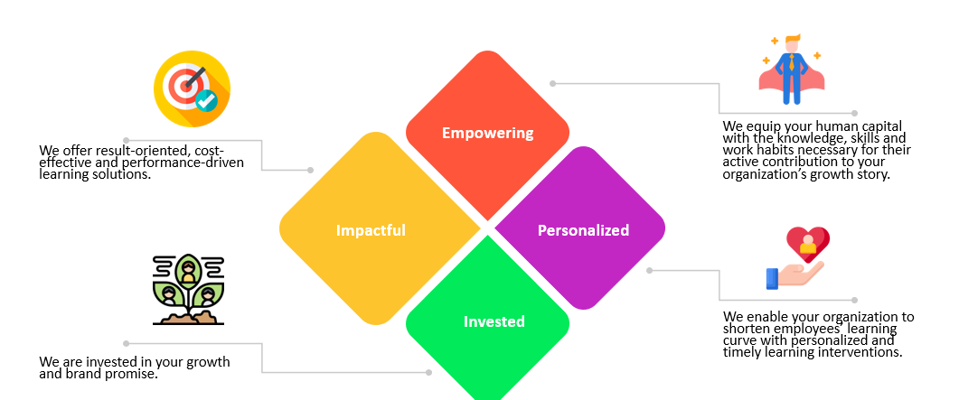

- We equip your human capital with the knowledge, skills and work habits necessary for their active contribution to your organization’s growth story.
- We enable your organization to shorten the employee learning curve with personalized and timely learning interventions.
- We offer result-oriented, cost-effective and performance-driven learning solutions.
- We are invested in your growth and brand promise.

Page 3 - Our Services:

We listen. We ask questions. We listen more. We collaborate and provide consultation and share recommendations. We partner with you to ensure a healthy, diverse, and breathable learning culture at your organization. We follow your branding and vision to create learning interventions that are evidence-based, authentic, performance-oriented, human-first and yet pocket-friendly.

Here are some of the key services that we excel at:

Needs Analysis

Needs Analysis is a formal, systematic process of identifying and evaluating training that should be done for the specific needs of an individual or group of employees, customers, suppliers, etc. Needs are often referred to as “gaps,” or the difference between the current state and the desired state.

We do a comprehensive Needs Analysis that covers your stakeholders, audience/learners, and processes/tasks. These discovery conversations and Analysis activities result in a detailed report capturing our findings and recommendations.

Strategic Planning

We highly recommend Strategic Planning in course development to uncover and bring in front the factors that may not seem too relevant but play a critical role in ensuring the success of any course. There has to be a 360-degree view of all the factors that may impact learning quality, including the culture of learning, alignment with organizational goals, communication or launch plan for the course or program. A few of the critical components include leveraging the findings from needs assessment, finding opportunities for reflection, and identifying the strengths, opportunities, and resources available within the organization to support the learning program.

Learning Ecosystem Building

We have helped organizations build a dependable and sustainable learning ecosystem – comprising data, information and technology that your people can seamlessly interact with for I3 (intuitive, interwoven and impactful) learning experiences. Your learning ecosystem also includes processes and best practices on the dos and don’ts of using these components.

Instructional Writing

Instructional Writing is the core of everything that we design and develop. We craft instructions that enable knowledge, behaviors and work habits. We follow instructional principles and guides known to deliver results and make the desired impact. In addition, we ensure that your instructional materials speak your organization’s language and tone (branding) and are based on your value proposition.

Graphic and Media Design

When we claim that we deliver impactful and intuitive learning solutions, relevant graphics and media play a great role in delivering that promise. They say, “A picture says a thousand words.” No doubt! We make sure that those 1000 words that the picture is saying are crisply covered as the text as well, for meeting the ‘accessibility’ needs and increasing the outreach. Keeping the visual design principles and your branding requirements in mind, we select media that looks like yours and speaks like yours.

eLearning Development

It takes a lot to bring that design and storyboard live. We know the tools well and know their strengths and limitations as well. We can recommend the tool you should choose for your learning – depending upon the nature of your training requirement. We will also ensure that your training is deployed in your system (if you’ve already invested in any) as per the latest technology and compliance requirements.

Learning Evaluation

Learning evaluation as a practice is highly recommended. Evaluation is often the starting point of many learning journeys. We are well-versed and trained in Kirkpatrick’s Four Levels of Evaluation and can help you assess the accomplishment of your training goals and chalk out the plan for bridging the gaps if any.

<blog for each of these above will be linked later>

<Button: Schedule a Consultation>

Delivery Formats

We understand that not all topics are fit to be taught as e-learning. For years, we have diversified into varied training development and delivery formats. As a result, we are equally skilled and experienced in leveraging the following diverse digitalization options while keeping the human touch alive.

<Use the below image for reference:

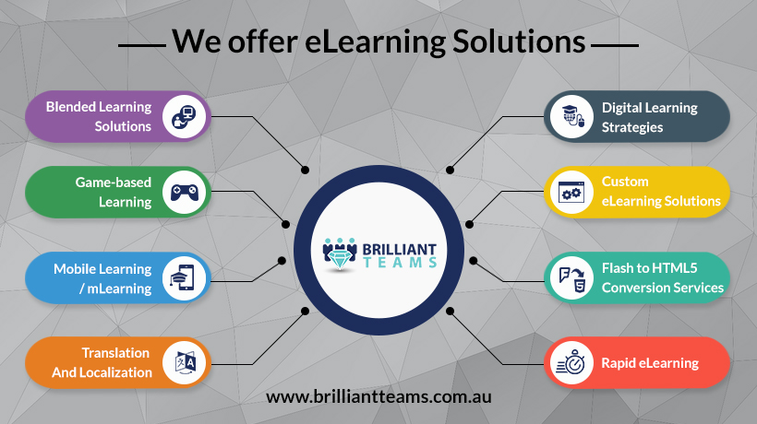 >

Self-paced Training/E-learning

Instructor/Virtual-led Training

Video-based Training

Blended Learning

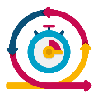Rapid Learning

Game-based Training

Simulation-based Training

Onbaording & Everboarding

Compliance Training

Leadership Training

<1 Portfolio video for each of these above will be linked>

<Button: Let’s Talk?>

Irrespective of the type of training or the format of training, we follow a client-centric agile framework that seamlessly fits with all our service offerings:

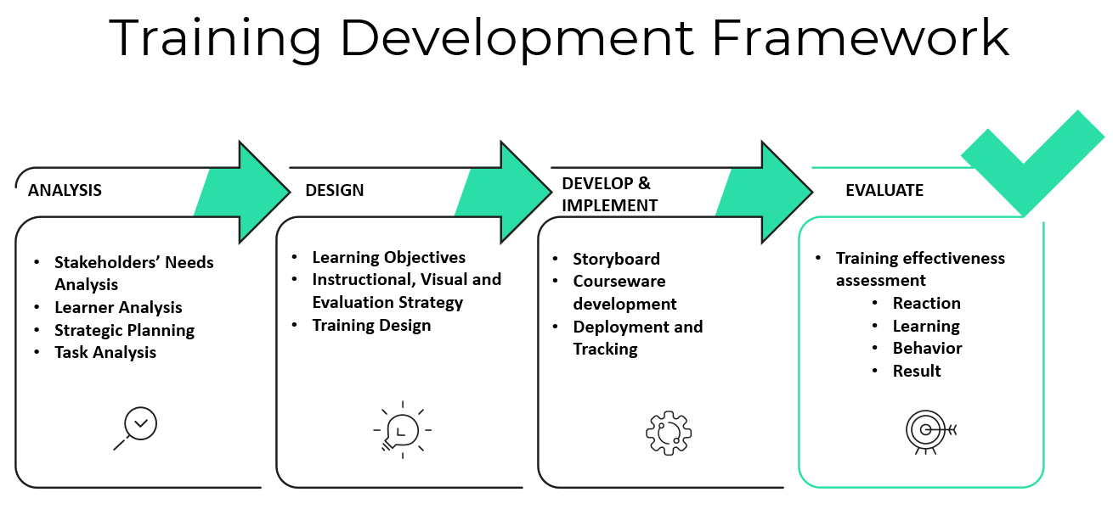

Page 4 – Portfolio:

DISCLAIMER: Please note that these samples showcase our Instructional Design skills. Different entities did the Media Design and Development for the samples shared here.

Page 5 - Blogs:

